Polymethine fluorophores for in vivo shortwave infrared imaging

Ellen M. Sletten

University of California, Los Angeles

Fluorescence imaging is a central tool for visualizing complex biological systems, yet the contrast and resolution attainable in vivo is limited by diffuse light originating from background and scattering at visible and near-infrared (NIR) wavelengths. Recently, the shortwave infrared region of the electromagnetic spectrum (SWIR, 1000 – 2000 nm) has emerged as an optimal region for in vivo fluorescence imaging due to its minimal light scattering and low tissue autofluorescence compared to the NIR. While the SWIR demonstrates great promise, suitable materials are needed with emission at these low energies for the development of optical contrast agents. Namely, non-toxic organic small molecules with bright emission > 1000 nm are necessary to expand both the basic science and clinical applications of fluorescence imaging.

Our group develops biocompatible polymethine fluorophores for the shortwave infrared region. We discovered a bright shortwave infrared emitter containing flavylium heterocycles that we deemed Flav7. We have systematically investigated Flav7 using physical organic chemistry approaches and can now predictably tune the absorption and emission properties. These insights have led to new SWIR fluorophores that enable multiplexed real time in vivo imaging and the fastest SWIR imaging to date.

Bio:
Prof. Ellen Sletten received her BS in Chemistry from Stonehill College in 2006. Ellen pursued her PhD in Chemistry at the University of California, Berkeley with Prof. Carolyn Bertozzi where she received an ACS Division of Organic Chemistry Fellowship. Her thesis work involved the optimization and development of bioorthogonal chemistries and their subsequent applications in labeling living systems. Upon graduation in 2011, Ellen joined the laboratory of Prof. Tim Swager at the Massachusetts Institute of Technology as an NIH Postdoctoral Fellow where she worked with soft fluorous materials for use in fluorescent sensors. Ellen joined the faculty in the Department of Chemistry and Biochemistry at UCLA as an Assistant Professor and John McTague Career Development Chair in 2015. Her group’s work focuses on the development of enhanced therapeutics and diagnostics. Ellen’s early career awards include an Alfred P. Sloan Fellow, NIH New Innovator Award, Mercator Fellow, and Hellman Fellow.

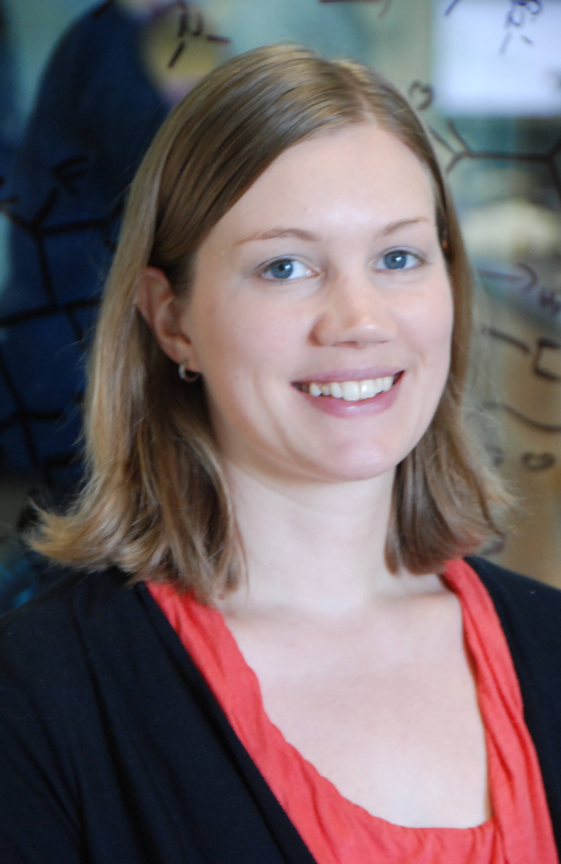
Photo credit: Penny Jennings

