Polariton chemistry: molecules in optical cavities
Joel Yuen-Zhou, Associate Professor, University of California San Diego

The strong coupling of ensembles of molecular transitions with confined electromagnetic fields in optical microcavities gives rise to molecular polaritons, hybrid light-matter quasiparticles. Can strong coupling fundamentally alter the chemical properties of matter? [1] In this talk, I’ll showcase some of these opportunities that we have been theoretically (and, together with our experimental collaborators) exploring in the past few years. I will briefly summarize the relevant time and energy scales associated with molecular polaritons [1]. Next, I will proceed to discuss the theoretical challenges to understand thermally-activated chemical reactions under vibrational strong coupling [2-3] and present a possible resolution for these problems involving polariton condensates [4]. I will conclude by showing how polariton-assisted remote-energy transfer (PARET) can give rise to intriguing new concepts such as remote control of chemical reactions [5-7].
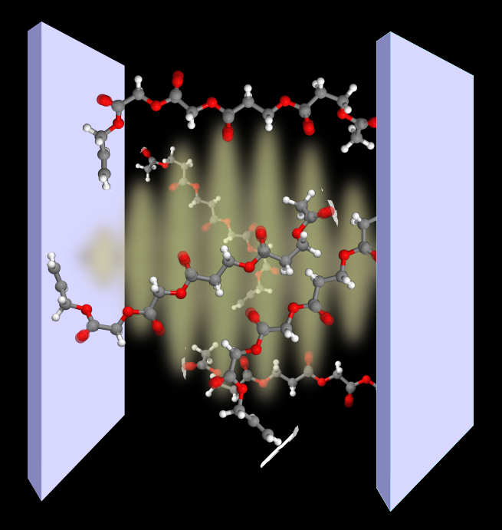
REFERENCES
[1] R. F. Ribeiro, L. Martínez-Martínez, M. Du, and J. Yuen-Zhou, Polariton chemistry: controlling molecular dynamics with optical cavities, Chem. Sci. 9, 6325-6339 (2018).
[2] J. Campos-González-Angulo, R. F. Ribeiro, and J. Yuen-Zhou, Resonant enhancement of thermally-activated reactions via vibrational polaritons, Nat. Commun., 10, 4685 (2019).
[3] J. Campos-Gonzalez-Angulo, R. F. Ribeiro, J. Yuen-Zhou, Polariton normal modes in transition state theory, J. Chem. Phys. 152, 161101 (2020).
[4] S. Pannir-sivajothi, J. A. Campos-Gonzalez-Angulo, L. A. Martínez-Martínez, S. Sinha, and J. Yuen-Zhou, Driving chemical reactions with polariton condensates, arXiV:2105.10449.
[5] M. Du, L. A. Martínez-Martínez, R. F. Ribeiro, Z. Hu, V. M. Menon, and J. Yuen-Zhou, Theory for polariton assisted remote energy transfer, Chem. Sci. 9, 6659-6669 (2018).
[6] M. Du, R. F. Ribeiro, L. A. Martínez-Martínez, and J. Yuen-Zhou, Remote control of chemistry in optical cavities, Chem 5, 5, 1167 (2019).
[7] B. Xiang, R.F. Ribeiro, M. Du, L. Chen, Z. Yang, J. Wang, J. Yuen-Zhou, and W. Xiong, Intermolecular vibrational energy transfer enabled by microcavity strong light-matter coupling, Science 368, 6491 (2020).

